# Apply filters to SQL queries

## Project description

Filter with AND, OR, and NOT

## Retrieve after hours failed login attempts

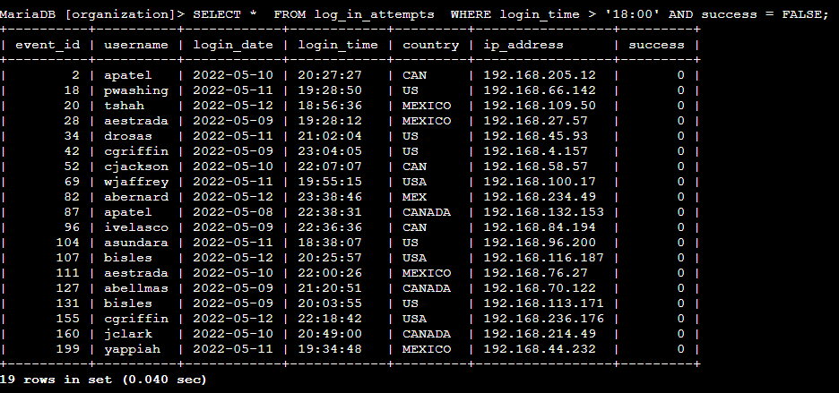

## 

## .

## 

## 

## Retrieve login attempts on specific dates

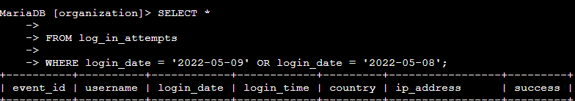



## Retrieve login attempts outside of Mexico

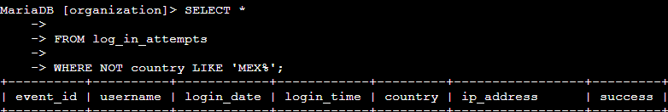



## Retrieve employees in Marketing

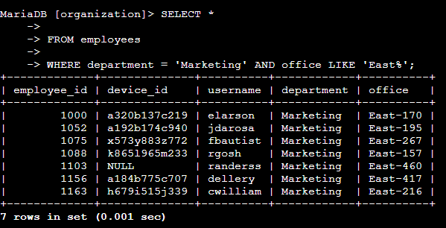

## Retrieve employees in Finance or Sales

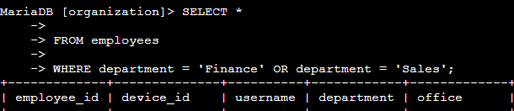[Add content here.]

## Retrieve all employees not in IT

## 

## Summary

After going through each SQL queries to retrieve information from a database and apply AND, OR, and NOT operators to filter SQL queries the applied filters helped accomplish the task from the employee table and going through each column.

## **What to Include in Your Response**

Be sure to include the following in your completed activity:

* Screenshots of your queries or typed versions of the queries
* Explanations of your queries
* A project description at the beginning
* A summary at the end
* Details on using **LIKE** to search for a pattern
* Details on filtering for dates and times
* Details on using **AND** and **OR** to filter on multiple conditions
* Details on using **NOT** in filters